ASSIGNMENT-4

21.# Number of rows for the pattern

rows = 5

# Loop to iterate through each row

for i in range(1, rows + 1):

# Print '*' 'i' times followed by a space

for j in range(i):

print('*', end=' ')

# Move to the next line after each row

print()

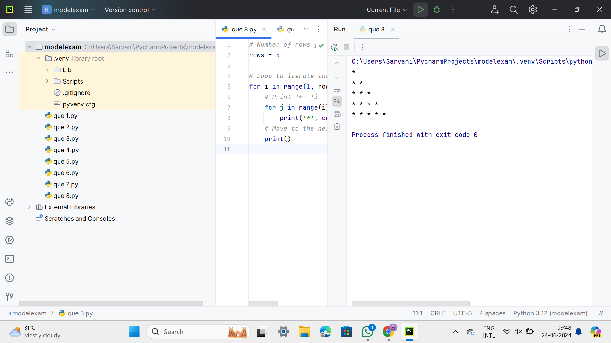

22. def count_vowels_and_consonants(statement):

vowels = "aeiouAEIOU"

num_vowels = 0

num_consonants = 0

for char in statement:

if char.isalpha():

if char in vowels:

num_vowels += 1

else:

num_consonants += 1

return num_vowels, num_consonants

def main():

statement = input("Enter a statement: ")

vowels_count, consonants_count = count_vowels_and_consonants(statement)

print(f"Number of vowels: {vowels_count}")

print(f"Number of consonants: {consonants_count}")

if vowels_count > consonants_count:

print("Vowels are more than consonants.")

elif consonants_count > vowels_count:

print("Consonants are more than vowels.")

else:

print("Number of vowels and consonants are equal.")

if __name__ == "__main__":

main()

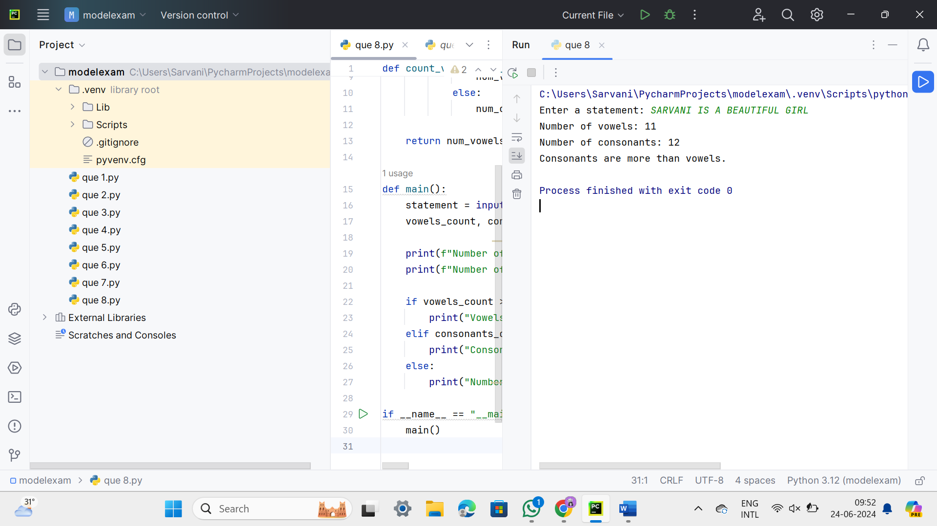

23. def add(x, n):

return x + n

def main():

try:

# Get the input values from the user

x = int(input("Enter the value of X: "))

n = int(input("Enter the value of N: "))

# Get the choice from the user

choice = int(input("Enter your choice (1 for addition): "))

if choice == 1:

result = add(x, n)

print(f"Add(X, N) = {result}")

else:

print("Invalid choice. Please enter 1 for addition.")

except ValueError:

print("Invalid input. Please enter integer values for X, N, and choice.")

if __name__ == "__main__":

main()

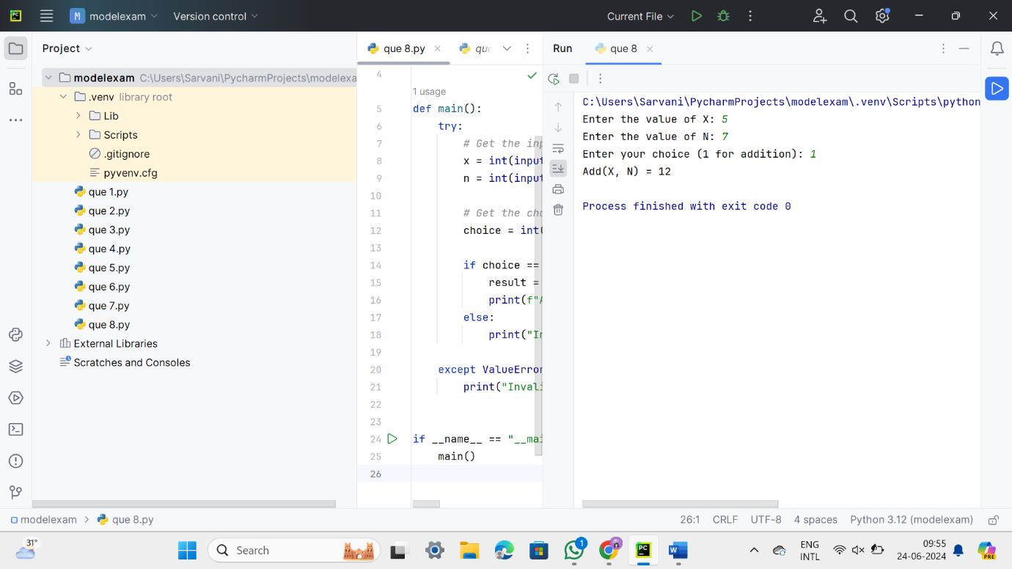

24. def calculate_averages():

positive_numbers = []

negative_numbers = []

while True:

try:

number = float(input("Enter a number (-1 to stop): "))

if number == -1:

break

elif number > 0:

positive_numbers.append(number)

elif number < 0:

negative_numbers.append(number)

except ValueError:

print("Invalid input. Please enter a valid number.")

if positive_numbers:

average_positive = sum(positive_numbers) / len(positive_numbers)

else:

average_positive = 0

if negative_numbers:

average_negative = sum(negative_numbers) / len(negative_numbers)

else:

average_negative = 0

print(f"Average of positive numbers: {average_positive}")

print(f"Average of negative numbers: {average_negative}")

if __name__ == "__main__":

calculate_averages()

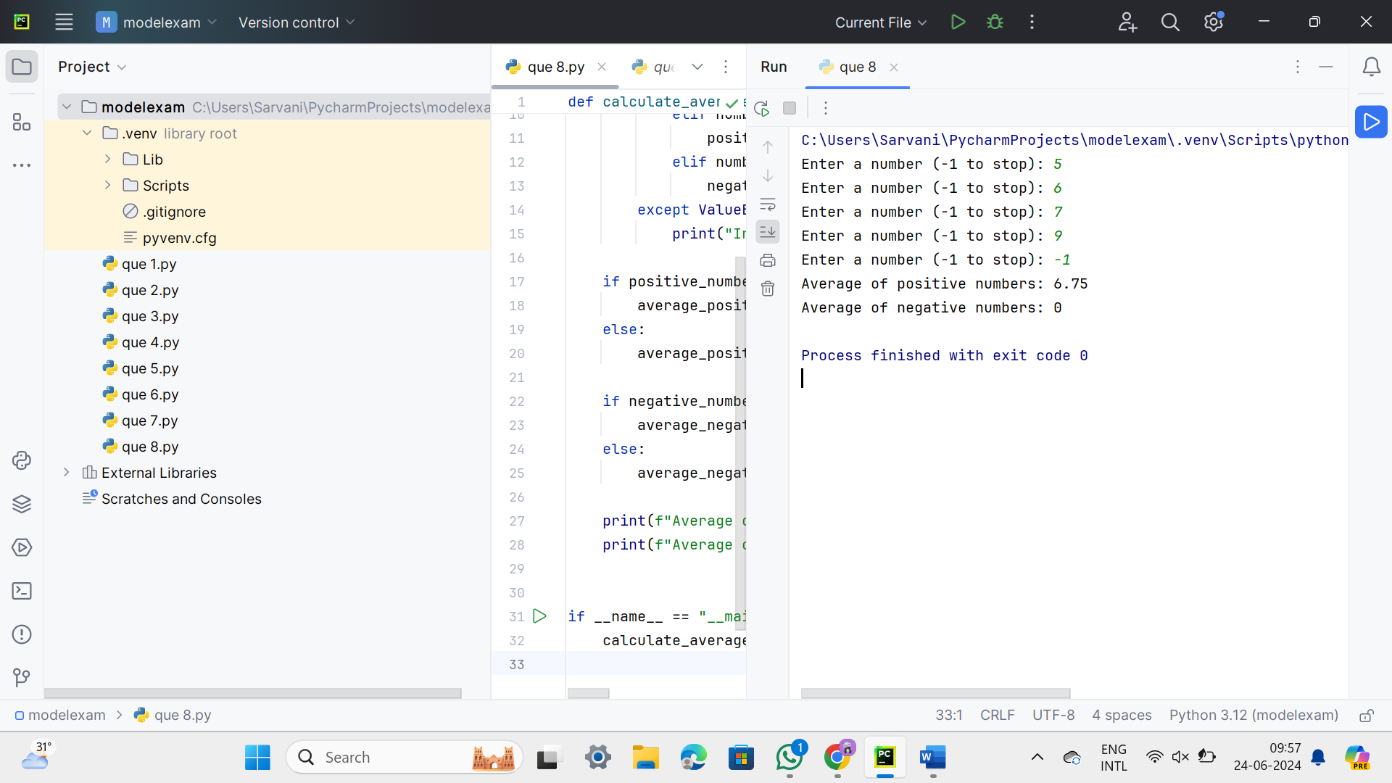

25. def reverse_words_in_string(s):

# Split the string into words

words = s.split()

# Reverse the list of words

reversed_words = words[::-1]

# Join the reversed words back into a string

reversed_string = ' '.join(reversed_words)

return reversed_string

def main():

# Input the string from the user

input_string = input("Enter a string: ")

# Call the function to reverse words in the string

reversed_string = reverse_words_in_string(input_string)

# Print the reversed string

print("Original string:", input_string)

print("Reversed words:", reversed_string)

if __name__ == "__main__":

main()

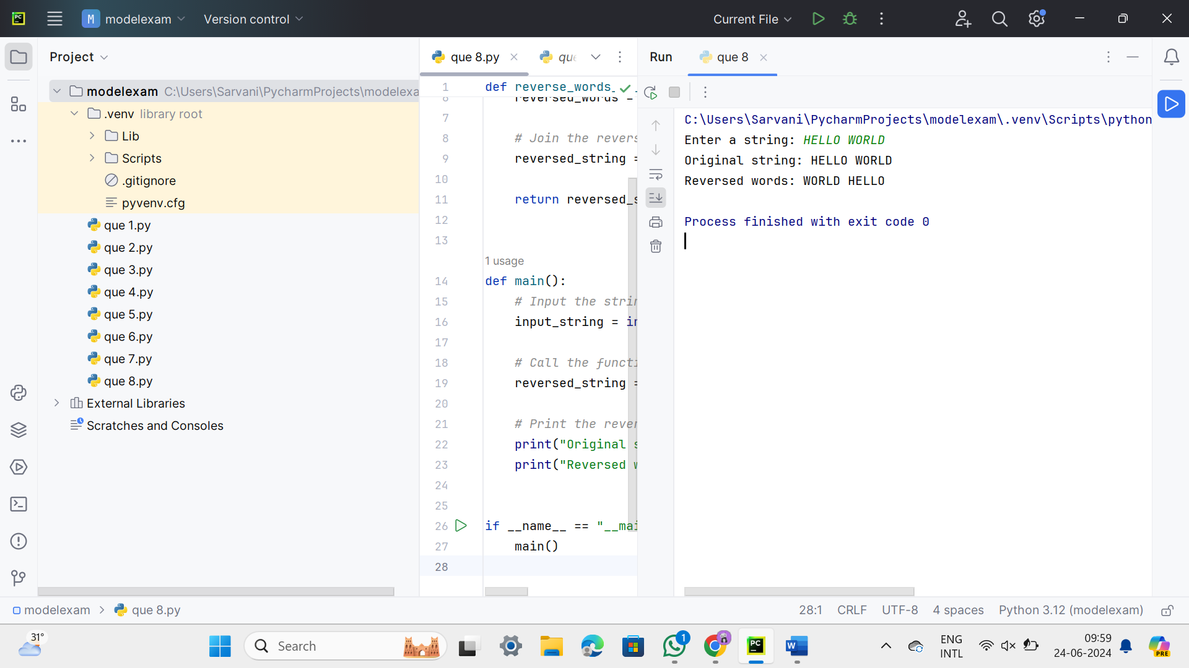

26. def count_vowels_and_consonants(statement):

vowels = "aeiouAEIOU"

num_vowels = 0

num_consonants = 0

for char in statement:

if char.isalpha():

if char in vowels:

num_vowels += 1

else:

num_consonants += 1

return num_vowels, num_consonants

def main():

statement = input("Enter a statement: ")

vowels_count, consonants_count = count_vowels_and_consonants(statement)

print(f"Number of vowels: {vowels_count}")

print(f"Number of consonants: {consonants_count}")

if vowels_count > consonants_count:

print("Vowels are more than consonants.")

elif consonants_count > vowels_count:

print("Consonants are more than vowels.")

else:

print("Number of vowels and consonants are equal.")

if __name__ == "__main__":

main()

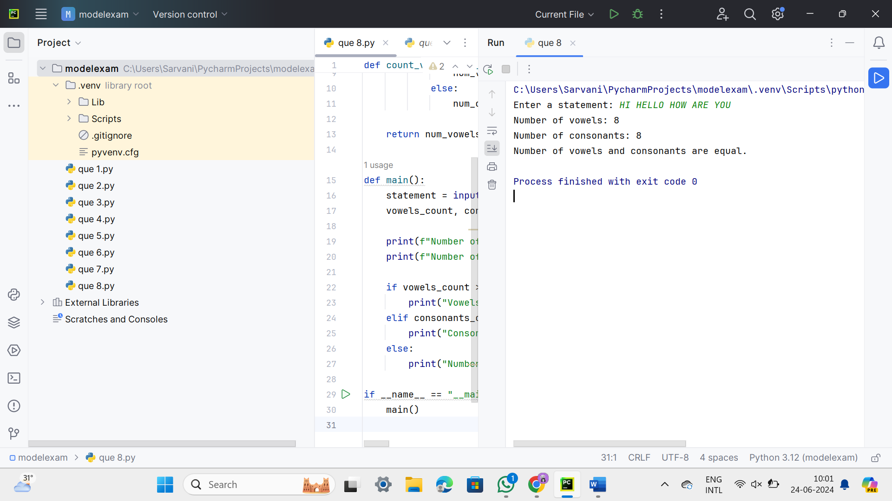

27. def calculate_tax(income):

if income <= 150000:

tax = 0

elif 150001 <= income <= 300000:

tax = (income - 150000) * 0.1

elif 300001 <= income <= 500000:

tax = 15000 + (income - 300000) * 0.2

else:

tax = 45000 + (income - 500000) * 0.3

return tax

def main():

try:

income = float(input("Enter the income: "))

if income < 0:

print("Income should be a positive number.")

else:

tax = calculate_tax(income)

print(f"Tax calculated: {tax}")

except ValueError:

print("Invalid input. Please enter a valid number.")

if __name__ == "__main__":

main()

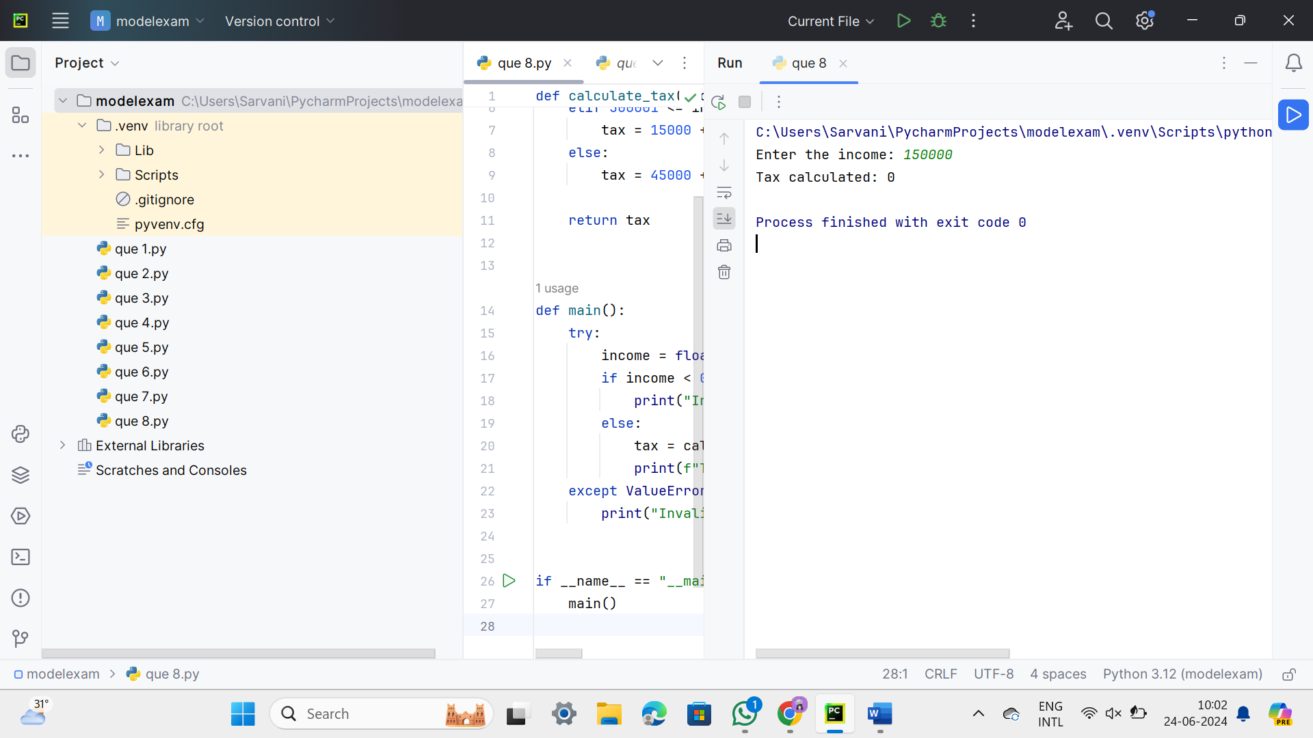

28.

def count_spaces_lines_vowels_consonants(filename):

vowels = "aeiouAEIOU"

space_count = 0

line_count = 0

vowel_count = 0

consonant_count = 0

try:

with open(filename, 'r') as file:

for line in file:

line_count += 1

space_count += line.count(' ')

for char in line:

if char.isalpha():

if char.lower() in vowels:

vowel_count += 1

else:

consonant_count += 1

elif char == ' ':

space_count += 1

except FileNotFoundError:

print(f"File '{filename}' not found.")

return None

return space_count, line_count, vowel_count, consonant_count

def main():

filename = input("Enter the filename: ")

result = count_spaces_lines_vowels_consonants(filename)

if result:

space_count, line_count, vowel_count, consonant_count = result

print(f"Number of spaces: {space_count}")

print(f"Number of lines: {line_count}")

print(f"Number of vowels: {vowel_count}")

print(f"Number of consonants: {consonant_count}")

if __name__ == "__main__":

main()

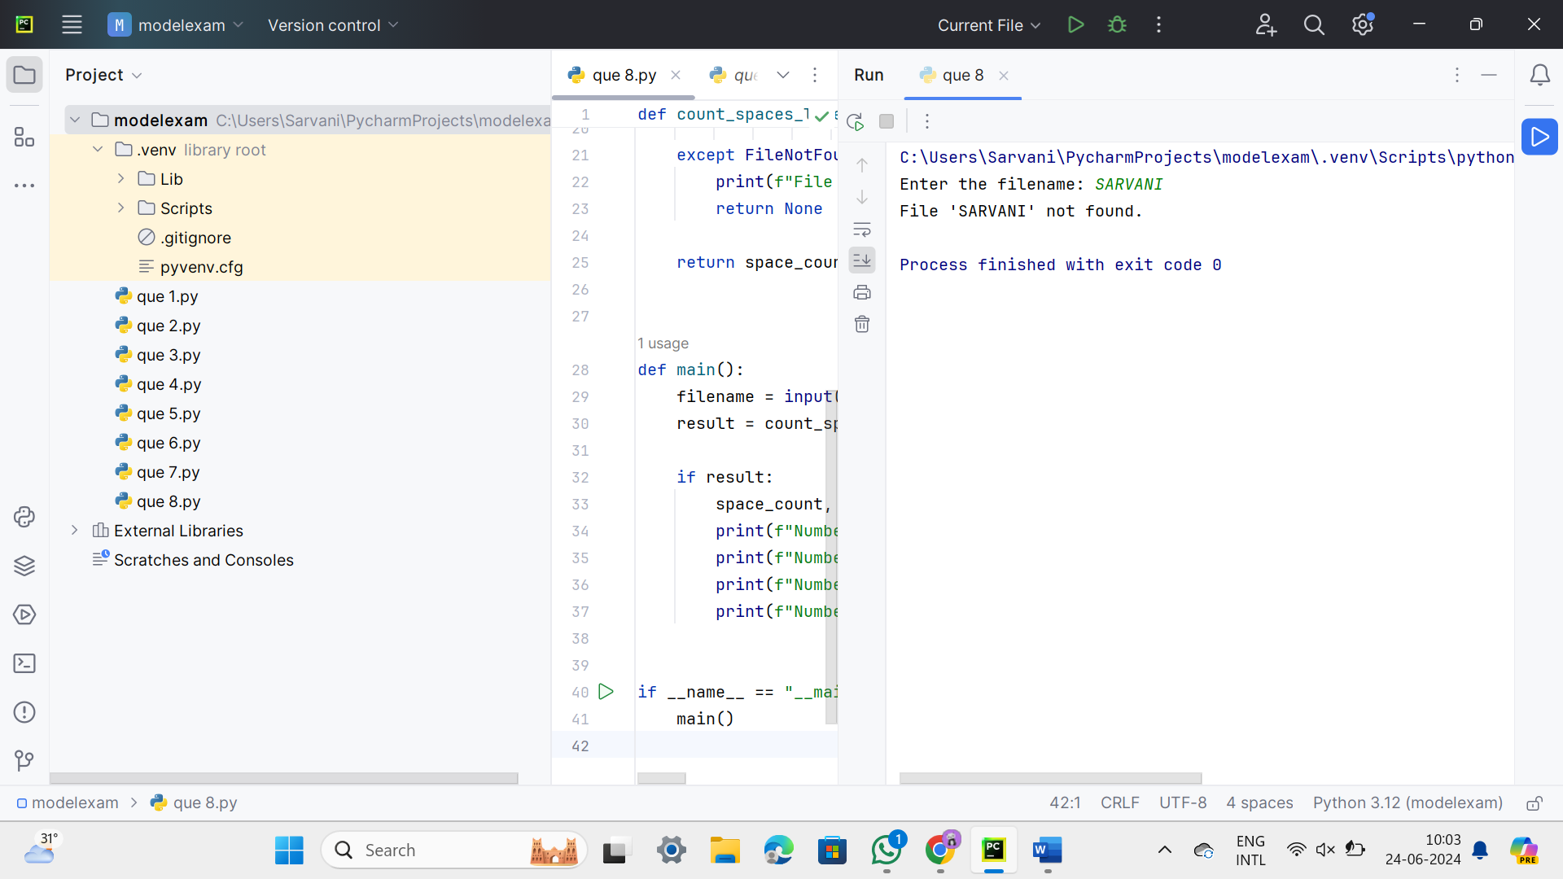

29.

def print_pattern(n):

for i in range(1, n + 1):

for j in range(1, i + 1):

print(f"{j / 10:.1f}", end=" ")

print()

def main():

n = 4 # Number of rows in the pattern

print_pattern(n)

if __name__ == "__main__":

main()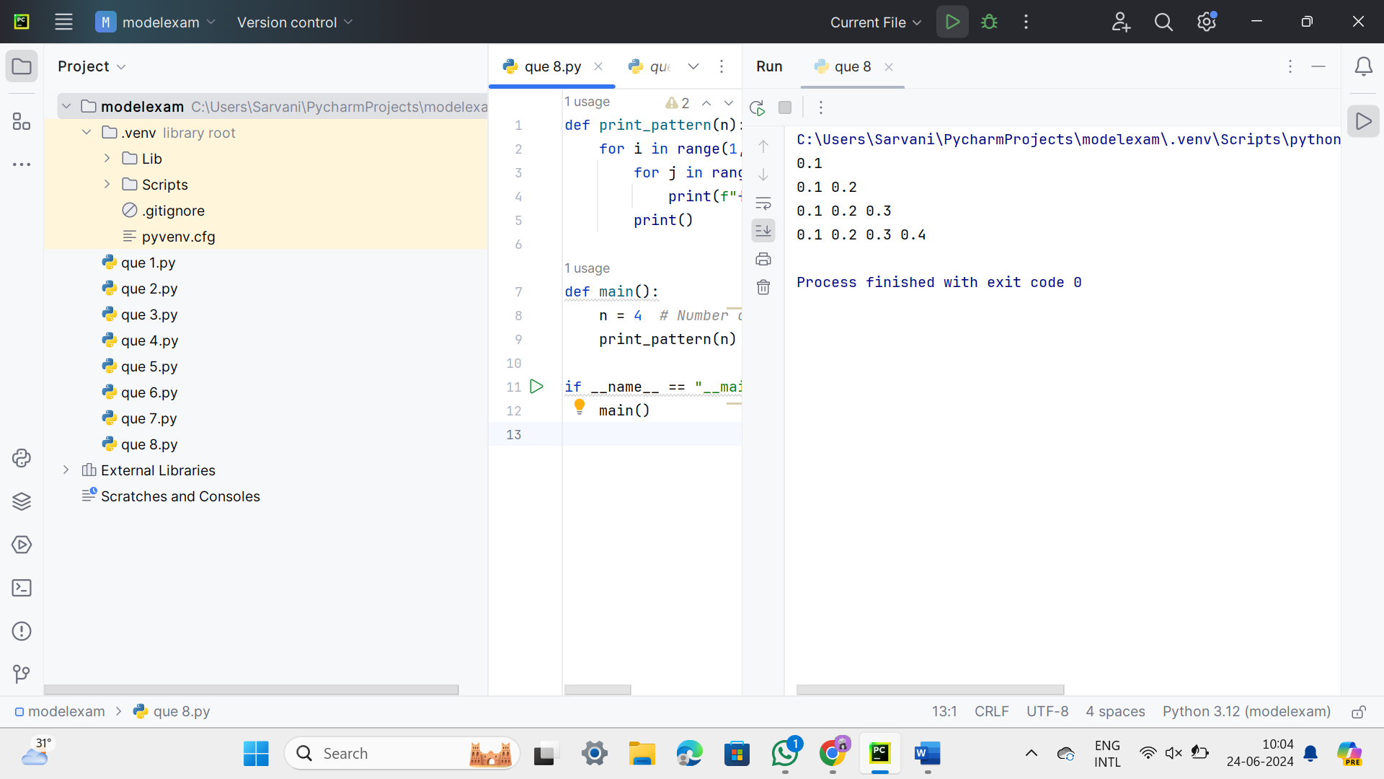

30.

def matrix_row_sum(matrix):

row_sums = []

for row in matrix:

row_sum = sum(row)

row_sums.append(row_sum)

return row_sums

def matrix_column_sum(matrix):

num_rows = len(matrix)

num_cols = len(matrix[0]) if matrix else 0

col_sums = [0] * num_cols

for j in range(num_cols):

for i in range(num_rows):

col_sums[j] += matrix[i][j]

return col_sums

def matrix_diagonal_sum(matrix):

num_rows = len(matrix)

num_cols = len(matrix[0]) if matrix else 0

if num_rows != num_cols:

return None # Not a square matrix

primary_diagonal_sum = sum(matrix[i][i] for i in range(num_rows))

secondary_diagonal_sum = sum(matrix[i][num_rows - 1 - i] for i in range(num_rows))

return primary_diagonal_sum, secondary_diagonal_sum

def main():

# Example matrix

matrix = [

[1, 2, 3],

[4, 5, 6],

[7, 8, 9]

]

# Calculate row sums

row_sums = matrix_row_sum(matrix)

print("Row sums:", row_sums)

# Calculate column sums

col_sums = matrix_column_sum(matrix)

print("Column sums:", col_sums)

# Calculate diagonal sums

diagonal_sums = matrix_diagonal_sum(matrix)

print("Primary diagonal sum:", diagonal_sums[0])

print("Secondary diagonal sum:", diagonal_sums[1])

if __name__ == "__main__":

main()

